TCP/IP LAYERS
- Physical Layer
The physical layer is concerned with sending raw bits between the adjacent nodes, across the communication medium.
Major duties:
  - Physical characteristics of interfaces and medium
  - Representation of bits
  - Data rate : transmission rate
  - Synchronization of bits
  - Line configuration
  - Physical topology
  - Transmission mode
- Data Link Layer
The data link layer is responsible for transmitting a group of bits between the adjacent nodes. The group of bits is called a frame.
Major duties:
  - Framing
  - Physical addressing
  - Flow control
  - Error control
  - Access control
  - Node to node delivery
- Network Layer
The network layer is responsible for the delivery of individual packets from the source host to the destination host.
Protocols in this layer are:
  - IP (Internet Protocol)
  - ARP (Address Resolution Protocol)
  - RARP (Reverse Address Resolution Protocol)
  - ICMP (Internet Control Message Protocol)
Major duties:
- Routing
- Logical addressing
- Address transformations
- Congestion control
- Source to destination error-free delivery

- Transport Layer
The transport layer is responsible for the delivery of a message from one process to another.
Protocols in this layer are:
TCP (Transmission Control Protocol)
UDP (User Datagram Protocol)
Major duties:
- Service port addressing
- Segmentation and reassembly
- Connection control
- Flow control
- Error control
- Application Layer
The application layer enables a user to access the network.
Major duties:
- Network abstraction
- File access and transfer
- Mail services
- Remote login
- World wide web(www)

PHYSICAL ADDRESS OR HARDWARE ADDRESS OF A COMPUTER
There are three methods to assign the hardware address to a computer:
- Static addresses: In this scheme, the physical address is hardcoded in the Network Interface Card (NIC) of the computer. This address does not change, and is provided by the network hardware manufacturer.
- Configurable addresses: In this case, the physical address is configured inside a computer when it is first installed at a site. Unlike a static address, which is decided and hardcoded by the hardware manufacturer, a configurable address allows the end customer to set up a physical address.
- Dynamic addresses: In this scheme, every time a computer boots, a server computer dynamically assigns it a physical address. This also means that the physical address keeps on changing every time a computer is switched off and on. A pool of free physical addresses is used to identify free addresses out of them, and one such free address is assigned to the newly booting computer.
(Instead of using a pool of free addresses, the dynamic address can be generated as a random number at run time, and it is ensured that the same random number is not used as a physical address by any other computer in that network.)
There is a unique physical address or hardware address for every computer on a network. This address gets stored on the NIC of that computer. The NIC actually fits into one of the slots of the motherboard of the computer, and therefore, is inside the computer. It acts an interface between a computer and its network.

When a computer wants to send a message to another computer on the same network, the following things happen:

- The computer sends a message to its NIC. The NIC stores this message in its memory.
- NIC now breaks the message into frames as appropriate to the underlying network protocol (e.g. Ethernet, Token Ring, etc.)
- The NIC inserts the source and destination physical addresses into the frame header. It also computes the CRC and inserts it into the appropriate field of the frame header.

- The NIC waits until it gets control, of the network medium. When it gets the control, it sends one or more frames on to the network.
- Each frame then travels over the network and is received by the respective NICs of all the computers on the network. Each NIC compares its own physical address with that of the destination address contained in the frame. If there is a mismatch, it discards the frame. Thus, only the correct recipient’s NIC accepts the frame, as its address matches with the destination address of the frame.
- The correct recipient receives all the frames in the same fashion.
- The recipient NIC computes the CRC for each frame, and matches it with that in the frame to check for error, and if acceptable, uses all these frames to reconstruct the original message after discarding the header, etc.
- The NIC of the recipient computer now hands over the entire frame to the recipient computer.

LOGICAL ADDRESSES

To guarantee uniform addressing for all computers on the Internet, the IP software defines an addressing mechanism that does not depend on the underlying physical addresses. This is called logical addressing. Whereas the physical address is hardcoded on the NIC inside a computer—and is thus a hardware entity, a logical address is purely an abstraction—and is thus a creation of the software. When a computer wants to communicate with another computer on the Internet, it uses the logical address of the destination computer.

IP DATAGRAMS

Version  ( 4 bits) | HLEN  (4 bits) | Service type  (8 bits) | Total length  (16 bits)
Identification  (16 bits) |  |  | Flags  (3 bits) | Fragmentation offset  (13 bits)
Time to live  (8 bits) |  | Protocol  (8 bits) | Header checksum  (16 bits)
Source IP address
(32 bits)
Destination IP address
(32 bits)
Data
Options

FIG: IP DATAGRAM

An IP datagram is a variable-length datagram. A message can be broken down into multiple datagrams and a datagram in turn can be fragmented into different fragments. The datagram can contain a maximum of 65,536 bytes. A datagram is made up of two main parts: the header and the data. The header consists of anywhere between 20 and 60 bytes and essentially contains information about the routing and delivery. The data portion contains the actual data to be sent to the recipient.
The various fields of a datagram are as follows:

- Version: This field currently contains a value 4, which indicates IP version 4 (IPv4). In future, this field would contain 6 when IP version 6 (IPv6) becomes the standard.
- Header Length (HLEN): Indicates the size of the header in a multiple of four-byte words. When the header size is 20 bytes, the value of this field is 5 and when the options field is at the maximum size, the value of HLEN is 15.
- Service type: This field is used to define service parameters such as the priority of the datagram and the level of reliability desired.
- Total length: This field contains the total length of the IP datagram.
- Identification: This field is used in situations when a datagram is fragmented. Whenever an IP datagram is fragmented, each of the fragments must have the same value in the identification field as it was in the original IP datagram. This helps the final destination host to reassemble the fragments into a single datagram based on the common identification number.
- Flags: It indicates whether a datagram can be fragmented in the first place – and if it can be fragmented, whether it is the first or the last fragment, or it can be a fragment somewhere in the middle, etc.
- Fragmentation offset: It is a pointer that indicates the offset of the data in the original datagram before fragmentation. This is useful when reconstructing a datagram from its fragments.
- Time to live: This field is used to determine how long the datagram can live. This helps the Internet infrastructure in preventing datagrams from living and moving on for too long, especially when there are network problems.

The datagram sender initializes this field to some value. As the datagram travels through routers, the value in this field is decremented each time. If the value in this field becomes zero or negative, the datagram is immediately discarded. No attempt is made to forward it to the next hop. This avoids a datagram travelling for an infinite amount of time through various routers, and therefore helps avoid network congestion.

- Protocol: This field identifies the transport protocol running on top of IP. This could be TCP or UDP.
- Source address: This field contains the 32-bit IP address of the sender.
- Destination address: This field contains the 32-bit IP address of the final destination.
- Options: This field contains optional information such as routing details, timing, management, and alignment. For instance, it can store the information about the exact route that the datagram has taken. This helps tracing and fault detection of datagrams.

The TCP/IP protocol suite uses the IP protocol for transmission of datagrams between routers. IP has two important properties: it is unreliable and it is connectionless.

IP is unreliable
It means that IP does not provide a guarantee that a datagram sent from a source computer will definitely arrive at the destination. In this sense, it is known as a best-effort delivery mechanism. IP does not have any error-checking or tracking mechanisms. Therefore, IP’s job is restricted to forwarding a datagram from its initial source on to the final destination through a series of routers. However, it does not in any way check to see if the datagram reached its next destination. IP assumes that the underlying medium is reliable and makes the best possible effort of delivery. There could be many reasons that cause datagrams to be lost—such as bit errors during transmission, a congested router, disabled links, and so on. IP lets reliability become the responsibility of the transport layer.

IP is connectionless
IP does not assume any connection between the sender and the receiver of datagrams. Instead, each datagram sent by IP is considered to be an independent datagram and it does not require any connection to be set up between the sender and the receiver before datagrams can be transmitted. Thus, a datagram has to contain not only data, but also additional information such as where the datagram originated and where it is heading. Here for each datagram, the route is decided at routing time. Therefore, IP is a packet switching technology.

CONCEPT OF IP ADDRESS

Each computer on the Internet is assigned a unique 32-bit number called Internet Protocol address, or in short, IP address. Each datagram travelling across the Internet contains the 32-bit address of the sender (source) as well as that of the recipient (destination). Therefore, to send any information, the sender must know the IP address of the recipient.

The IP address consists of three parts: a class, a prefix (or network number) and a suffix (or host number). The IP address space is divided into three primary classes named A, B and C. In each of these classes, a different number of bits are reserved for the network number and the host number portions of an IP address. In addition to the three primary classes, there are two more classes named D and E, which serve a special purpose. The prefix denotes the physical network to which the computer is attached. The suffix identifies an individual computer on that network. For this, each physical network on the internet is assigned a unique network number - this is the prefix portion of the IP address. Since no two network numbers across the Internet can be the same, assigning network numbers must be done at the global level. The host number denotes the suffix. Host is just another name for a computer on the Internet. The assignment of host numbers can be done locally.

Class | Network number | Host number

Fig: Three parts of IP address

Classes of IP Addresses

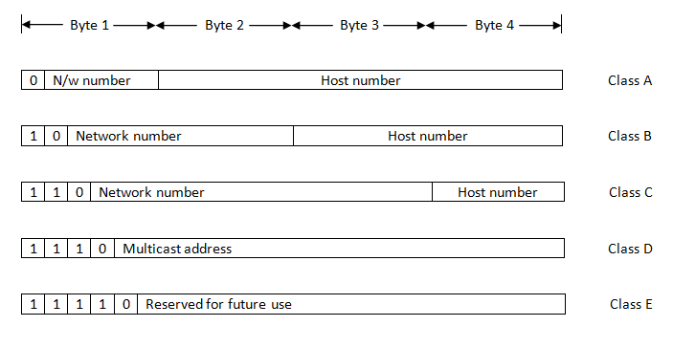
Fig: Classes of IP addresses
The IP address space is divided into three primary classes named A, B and C. In each of these classes, a different number of bits are reserved for the network number and the host number portions of an IP address. For example, class A allows 7 bits for the network number and 24 bits for the host number - thus allowing fewer networks to have a large number of hosts, each. Class B is somewhere in-between. It allows 14 bits for the network number and 16 bits for the host number. On the other hand, class C reserves 21 bits for the network number and just 8 bits for the host number - thus useful for a large number of networks that have a smaller number of hosts. This makes sure that a network having a large number of hosts can be accommodated in the IP addressing scheme with the same efficiency as a network that has very few hosts attached to it. In addition to the three primary classes, there are two more classes named D and E, which serve a special purpose. Class D is used for multicasting, which is used when a single message is to be sent to a group of computers. For this to be possible, a group of computers must share the common multicast address. Class E is reserved for future use.
If the first bit in the IP address is a 0, it must be an address belonging to class A. Similarly, if the first two bits are 10, it must be a class B address. If the first three bits are 110, it belongs to class C. Finally, if the first four bits are 1110, the IP address belongs to class D. When class E would come in use, the first five bits would indicate this fact by having a value of 11110.
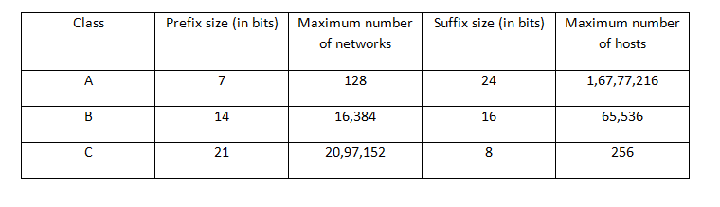Fig: Maximum number of networks and hosts in each class
Direct and indirect delivery
There are two possibilities in case of data transmission in the form of IP datagrams from a source to a destination:
- The source and the destination are on the same physical network
In this case, we call the flow of packets from the source to the destination as direct delivery. To determine this, the source can extract the network number portion of the destination host and compare it with the network number portion of itself. If the two match, the source knows that the destination host is on the same physical network. Therefore, it need not go to its router for delivery, and instead, can use the local network mechanism to deliver the packet
- The source and the destination are on different physical networks.
In this case, we call the flow of packets from the source to the destination as indirect delivery. To determine this, the source can extract the network number portion of the destination host and compare it with the network number portion of itself. Since the two do not match, the source knows that the destination host is on a different physical network. Therefore, it needs to forward the packet to the router, which, in turn forwards the packet to the destination.

Dotted Decimal Notation
The 32 bits of an IP address are divided into four octets. Octets are the same as bytes. Each octet contains eight bits. Each octet is then translated into its equivalent decimal value and the four octets are written one after the other, separated by dots.
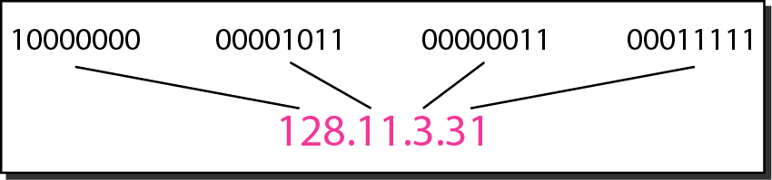
Fig: Equivalence between Binary and Dotted Decimal Notation

Routers and IP addresses
A router is a special-purpose computer that is mainly used for forwarding datagrams between computer networks over the Internet. This means that a router connects two or more networks. As a result, a router needs to have as many IP addresses as the number of networks that it connects: usually at least two. In the following figure, router R1 connects two networks: an Ethernet (whose IP network number is 130.100.17.0) and a Token Ring (whose IP network number is 231.200.117.0). Similarly, router R2 connects the same Token Ring network to a WAN whose IP address prefix is 87.12.0.0, which is a class A network. The routers are assigned IP addresses for both the interfaces that they connect to. Thus, as figure shows, router R1 has an IP address 130.100.17.7 on the Ethernet LAN, whereas it has an IP address of 231.200.117.19 on the Token Ring network. The same thing can be observed in R2. In general, if a router connects to n networks, it will have n IP addresses.
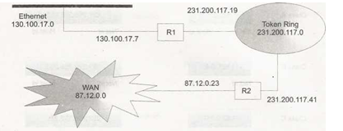
Fig: A router has two or more IP addresses
IP version 6
The new practical version of IP, called IP version 6 (IPv6), also known as IP Next Generation (IPng) retains all the good features of IPv4 and adds newer ones. Most importantly, it uses a 128-bit IP address. It is assumed that IP address of this size would be sufficient for many more decades. Apart from this, IPv6 also has support for real-time audio-video and collaborative technologies (analogous to virtual meeting among people, over the Internet). It is expected that IPv4 would be phased out in the next few years and IPv6 would take over from it.
Address Resolution Protocol
The process of obtaining the physical address of a computer based on its IP address, in order to be able to finally actually transmit the frame/datagram over the network, to which the node belongs, is called address resolution. ARP takes the IP address of a host as input and gives its corresponding physical address as the output.
There are three methods for obtaining the physical address based on an IP address. These three methods are as follows:
- Table lookup: Here, the mapping information between IP addresses and their corresponding physical addresses is stored in a table in the computer’s memory. The network software uses this table when it needs to find out a physical address, based on the IP address.
- Closed-form computation: Using carefully computed algorithms, the IP addresses can be transformed into their corresponding physical addresses by performing some fundamental arithmetic and Boolean operations on them.
- Message exchange: In this case, a message is broadcasted to all the computers on the network in the form Are you the one whose IP address is X? If so, please send me your physical address. The computer whose IP address matches X (the broadcasted IP address), sends a reply, and along with it, its physical address to the broadcasting computer. All other computers ignore the broadcast.
ARP using Message Exchange
Any time a host or a router needs to find the physical address of another host on its network, it creates a special datagram called ARP query datagram that includes the IP address of the destination whose physical address is needed. This special datagram is then broadcasted over the network.
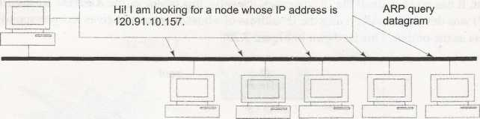
- A router or a host sends an ARP query datagram.
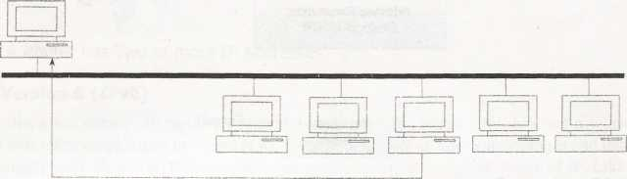

I am the one whose IP address is 120.91.10.157. My physical address is A71FG1415TA.
ARP response

- Only the concerned host replies and also sends its physical address.

As shown in Figure, every host on the network receives this datagram even if the destination physical address is absent. This is because this is a broadcast request, which means that the datagram should go to all the hosts in the network. Every host then checks the IP address of the destination mentioned in the ARP query datagram with its own. If it does not match, it discards it. However, if it matches, it sends back its physical address to the original node. Thus, only one of the hosts on the network would respond back to the ARP query datagram. This whole process, datagram/response formats etc together constitute the Address Resolution Protocol (ARP).
ARP caching
ARP learns from the past experiences. Once it knows the relationship between a particular IP address and a physical address, it stores this information in a table. This is known as ARP caching. Thus, the next time a host wants to send a datagram to the same destination, it need not again broadcast the ARP query datagram to find the physical address associated with it. Instead, it first checks it in its ARP cache. Only if the IP address (and therefore, the physical address) of the destination host is not found in the table, it broadcasts the ARP query datagram.
ARP is local
The address resolution performed by ARP is always local to a network. A computer can resolve another computer’s address only if both the computers are on the same network. The reason is that since physical networks are of different kinds and use different addressing mechanisms, a computer must not attempt to resolve another computer’s address if they are on different physical networks.
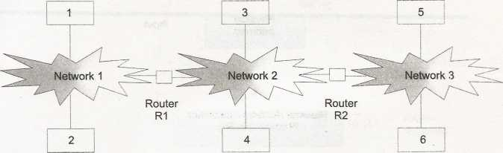
Fig: Address resolution is always local
The figure shows computers 1 and 2 attached to the same network. Similarly, computers 3 and 4 are attached to another network. A third network has computers 5 and 6 attached to it. The networks are then connected together by routers R1 and R2. Suppose computer 2 wants to send a datagram to computer 5. This would work as follows:
- Computer 2 realizes that it cannot resolve the address of computer 5. Instead, it knows that it has to forward the datagram to router Rl. Therefore, it resolves Rl’s address using ARP. and sends the datagram to Rl. Rl has two addresses corresponding to two networks that it connects to. This address resolution process would have given the physical address of the router on the same network (i.e. network 1).
- The protocol software on router Rl, in turn, realizes that it cannot reach computer 5, and therefore, cannot resolve its address. Thereforee, it forwards the datagram to router R2. To achieve this, it uses the second address of itself; i.e. the one on network 2. It now resolves the address of R2 using ARP. This is R2’s address on network 2. With this address, it now forwards the datagram to R2.
- Router R2 knows that computer 5 connects to the same physical network to which it is connected. Therefore, it resolves the address of computer 5 using ARP and forwards the datagram to computer 5.

Reverse address resolution protocol (RARP)
The Reverse Address Resolution Protocol (RARP) is used to obtain the IP address of a host based on its physical address. That is, it performs a job exactly opposite to that of ARP.
In the following situations, the computer does not know its own IP address.
Firstly, a host may not have a hard disk at all (e.g. a diskless workstation). Secondly, when a new host is being connected to a network for the very first time, it does not know its IP address. Finally, a computer may be discarded and replaced by another computer, but the same network card could be reused.
Fig: Reverse address resolution protocol (RARP)
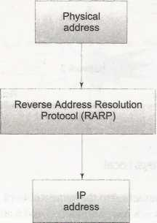
In RARP, the host interested in knowing its IP address broadcasts an RARP query datagram. This datagram contains its physical address. Every other computer on the network receives the datagram. All the computers except a centralized computer (the server computer) ignore this datagram. However, the server recognizes this special kind of datagram and returns the broadcasting computer its IP address. The server contains a list of the physical addresses and their corresponding IP addresses for all diskless workstations.
Internet Control Message Protocol (ICMP)
ICMP enables the detection and reporting of problems in the Internet. However, it does not play any role in the correction of these problems.
How ICMP works?
ICMP works by sending an error message for a specific reason to the concerned host.
- Destination unreachable: Whenever a router realizes that a datagram cannot be delivered to its final destination, it sends a Destination unreachable message back to the host which sent the datagram originally. This message also includes a flag to indicate whether the destination host itself is unreachable, or whether the network containing the end destination is down.

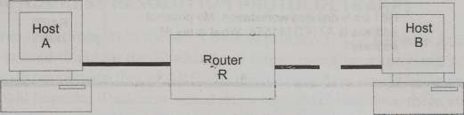
Fig: connection between a host and a router is lost
- Source quench: There are occasions when a router receives so many datagrams that it cannot handle them. That is, the number of datagrams arrived at a router could exhaust the size of its memory buffer, where it usually stores these datagrams temporarily before forwarding them to the next router or the final destination. In such situations, any additional datagrams that the router receives must be discarded. In order to prevent such a situation, the router sends a Source quench message to all the senders who are sending it more datagrams. This signals the hosts sending datagrams to the router, that they should not send any more datagrams to that router. Rather, they should wait for some time before transmitting more datagrams or before re-transmitting the datagrams discarded by the router.

- Redirect: When a host creates a datagram for sending it to a particular destination, it first sends it to the nearest router. The router then forwards it on to another router, or to the end destination, if the end destination is directly reachable. However, during the journey of a datagram via one or more routers like this, it could happen that a router incorrectly receives a datagram, which is not on the path of the end destination. The datagram should, instead, go to another router. In such a case, the router that received the datagram incorrectly sends a Redirect message to the host or network from where it received that datagram.

- Time exceeded: Every IP datagram contains a field called Time to live. This field is used to determine how long the datagram can live. This helps the Internet infrastructure in preventing datagrams from living and moving on for too long, especially when there are network problems. For instance, suppose that host A sends a datagram to host B and that the two hosts are separated by a number of intermediate routers. Initially, host A sets this value based on the expected number of routers that the datagram is expected to pass through (may be a little more than that number). Then every time a datagram moves from A to B via these routers, the router reduces the amount of the field Time to live of that datagram by a certain value before forwarding it to the next router. If a router receives this field with the value of Time to live being zero, it means that the datagram must be discarded, as it is moving through too many routers. Therefore, the router discards this datagram. It then communicates this fact to the original sending host by a Time exceeded ICMP message. The original host can then take an appropriate corrective action, such as choosing another router, or waiting for some time before retransmission.

To avoid sending long text messages such as Destination unreachable, ICMP actually maps these messages to error codes, and just sends the error code to the host. For instance, when a router has to send a destination unreachable message to a host, it sends an error code of 3.

TCP/IP Part II (TCP, UDP)
The transport layer runs on top of the Internet layer and is mainly concerned with the transport of datagrams from the source to the ultimate destination. In TCP/IP, the transport layer is represented by two protocols: Transmission Control Protocol (TCP) and User Datagram Protocol (UDP).
Features of TCP:
- Reliability: TCP ensures that any data sent by a sender finally arrives at the destination as it was sent. This means that there cannot be any data loss or change in the order of the data. Reliability has four important aspects: error control, loss control, sequence control and duplication control.
- Point-to-Point communication: This is also called port-to-port communication. Each TCP connection has exactly two end-points: a source and a destination. This communication is full duplex, which means that both the participating computers can send messages to each other simultaneously.
- Connection-oriented: TCP is connection-oriented. The connections provided by TCP are known as virtual connections. The term virtual is used because physically there is no direct connection between the computers—it is achieved in the software, rather than in the hardware. This means that a connection must be established between the two ends of a transmission before either can transmit data. Thus, an application must first request TCP for a connection to a destination and only when that connection is established can it perform the data transmission.
TCP acts as a multiplexer-demultiplexer
The TCP software acts as a data multiplexer at the sender's end. The TCP software receives data from the applications, multiplexes them and gives it to the local IP software. That is, regardless of which application (FTP, TELNET, etc.) is sending data, TCP puts this data into TCP segments and gives it to IP. IP adds its own header to each such TCP segment to create an IP datagram out of it, and from there, it is converted into a hardware frame and sent to the appropriate destination.
At the destination’s end, the IP software receives this multiplexed data (i.e. an IP datagram after removing the frame header) from its physical layer, and gives it to the local TCP software. The TCP software at the destination’s end then demultiplexes the data (i.e. first removes the IP header to extract the TCP segment, and then removes the TCP header to get the original message) and gives it to the concerned application.

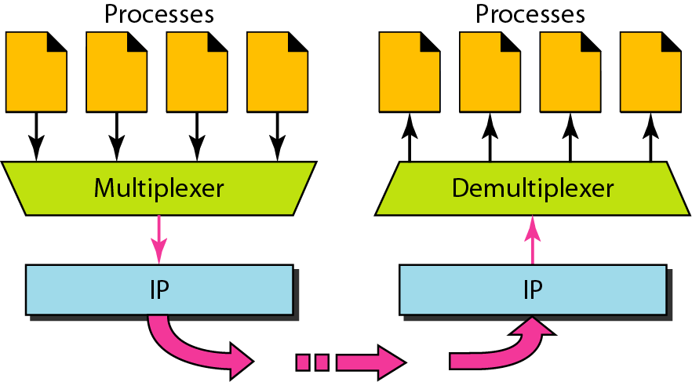
Fig: TCP acts as a multiplexer-demultiplexer

Ports and Sockets
Port Numbers:
Applications running on different hosts communicate with TCP with the help of a concept called ports. A port is a 16-bit unique number allocated to a particular application.
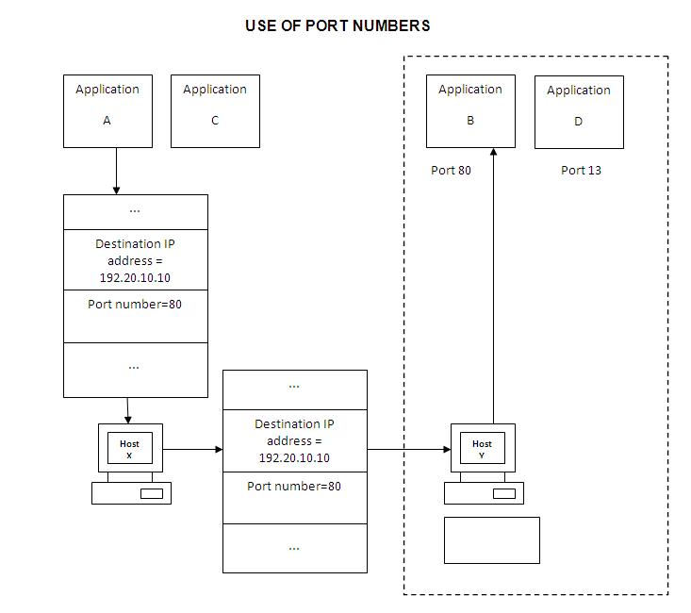
Fig shows an example of using a port number in conjunction with an IP address. As shown in the figure, an application A running on computer X wants to communicate with another application B running on computer Y. Application A provides the IP address of computer Y (i.e. 192.20.10.10) and the port number corresponding to application B (i.e. 80) to computer X. Using the IP address, computer X contacts computer Y. At this point, computer Y uses the port number to redirect the request to application B.
When an application wants to communicate with another application on a remote computer, it first opens a TCP connection with the application on the remote computer using the IP address of the remote computer and the port number of the target application. Thus, the IP protocol enables communication between two different computers, whereas TCP enables the communication at a higher level than IP—between two applications on these different computers.
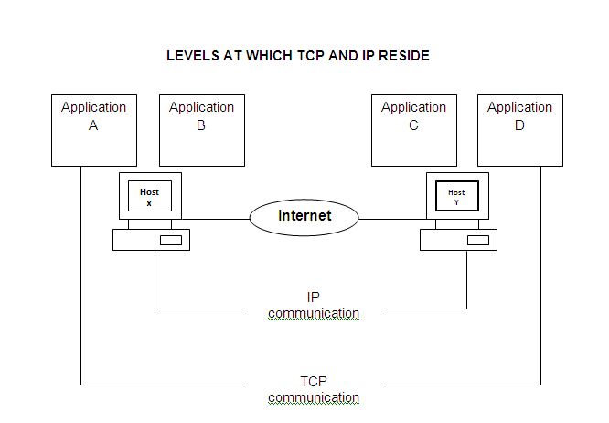
Well known ports: The standard applications on a server are known to execute on specific ports, so that the client has no ambiguity while requesting for a TCP connection with the server. For instance, the HTTP protocol almost always runs on port 80 on the server, waiting to accept TCP connection requests from clients.
Sockets:
The term socket address or simply socket is used to identify the IP address and port number concatenated together. For instance, port 80 on a computer 192.20.10.10 would be referred to as socket 192.20.10.10:80. A pair of sockets identifies a unique TCP connection between two applications on two different hosts.

